**Big Data Technologies and Applications**

**Final Project**

**Recipe for Exploratory Analysis and**

**Prediction Model of Amazon Helpfulness Score**

Group We’R, Ayşe Çetinel Yağşi, Engin Erdemli, Erçin Eldeleklioğlu, Yonus Kula

*Istanbul Technical University, MSc in Big Data and Business Analytics*

1. **Amazon Elastic MapReduce System Configuration**

Go to Amazon Web Services EMR and click on create cluster. Follow the steps below to replicate our cluster. Our cluster consists of 1 master and 5 slaves of 16vCore and 32 GiB memory in Frankfurt zone.

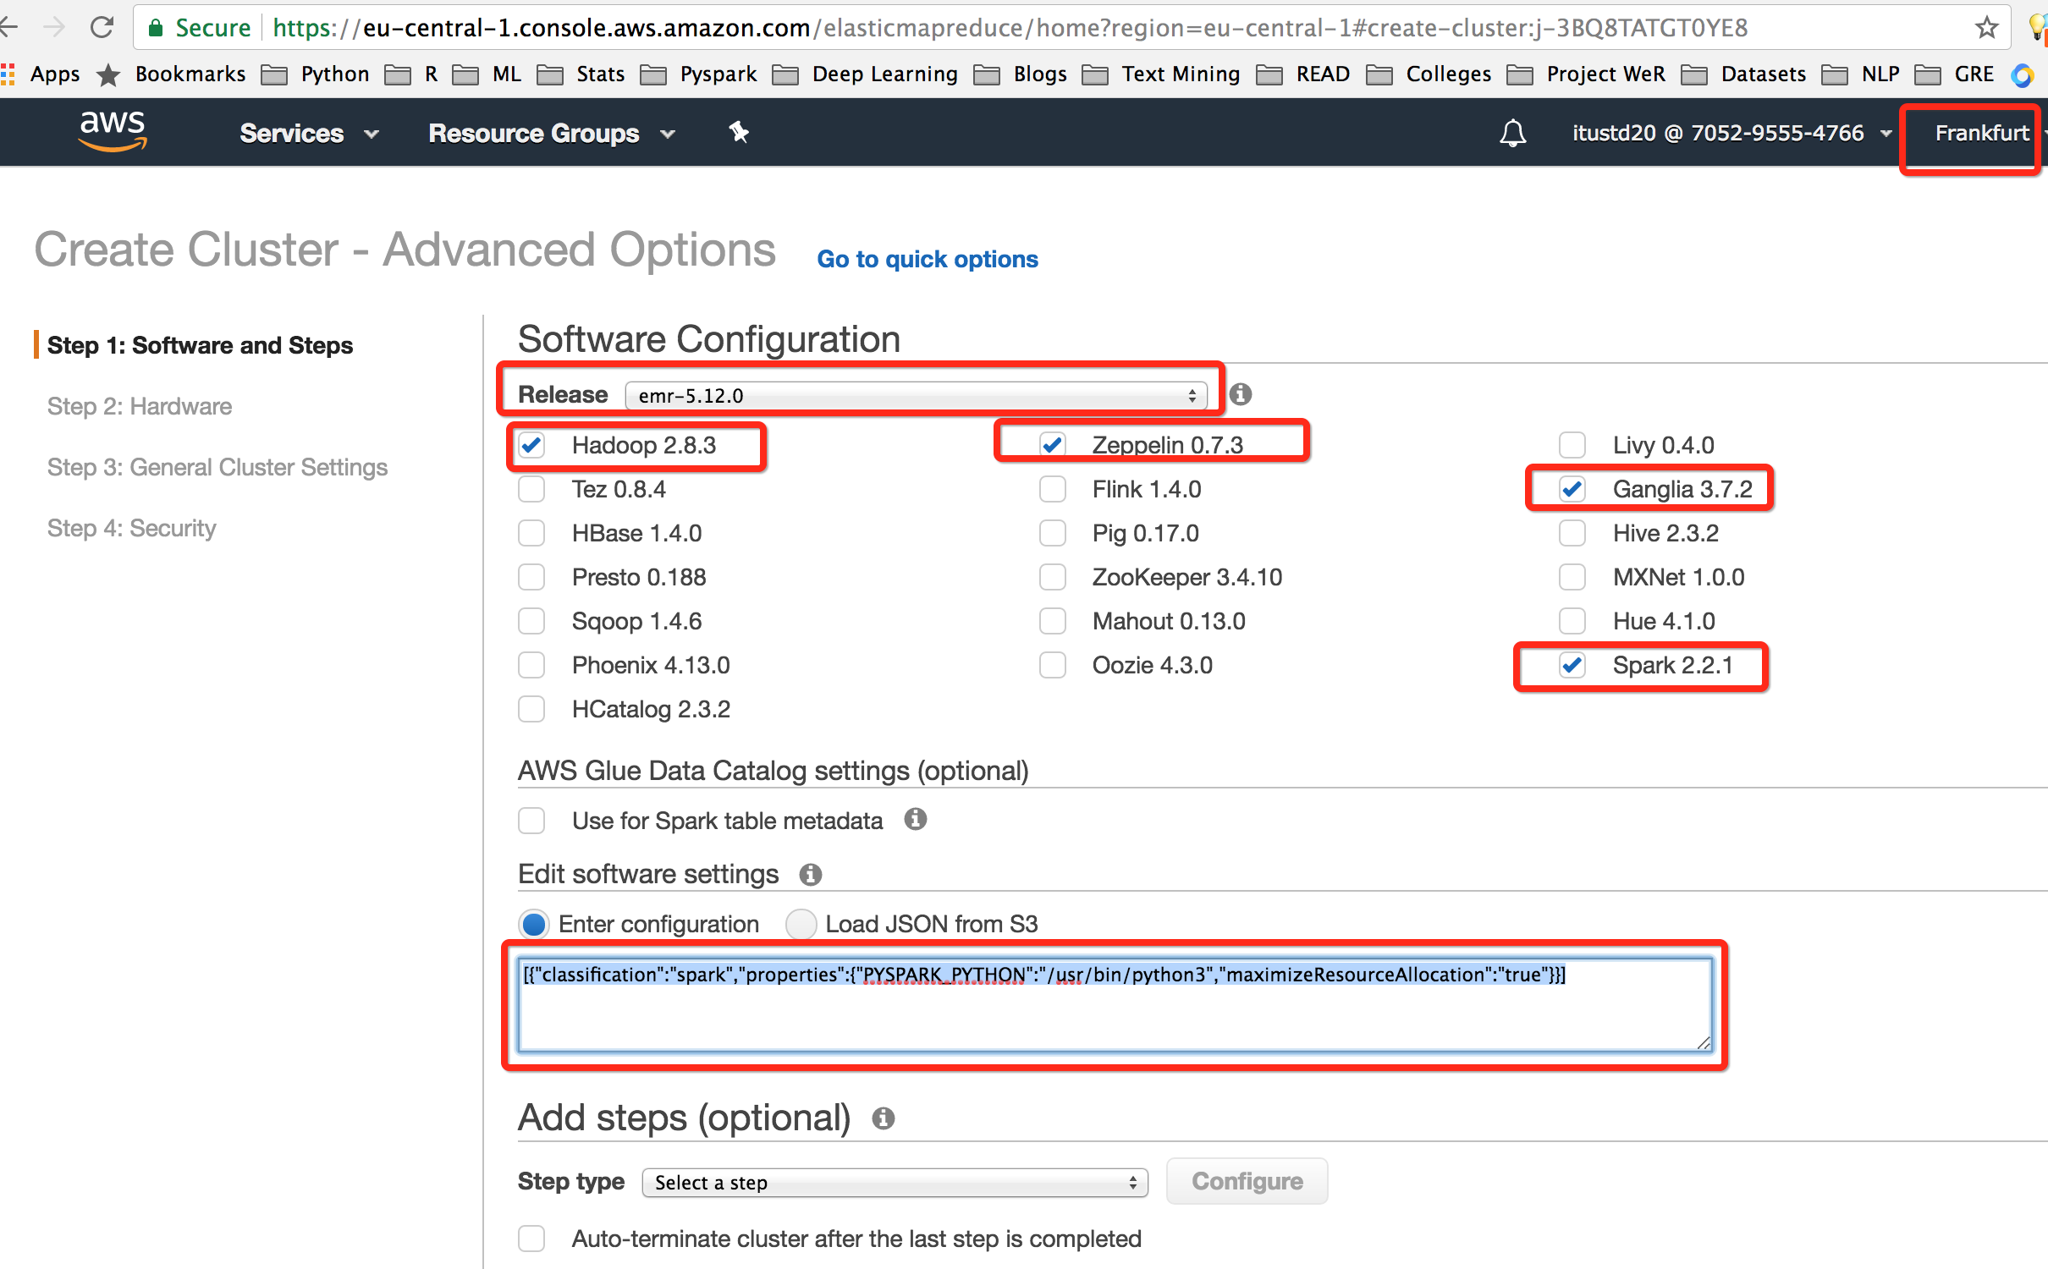

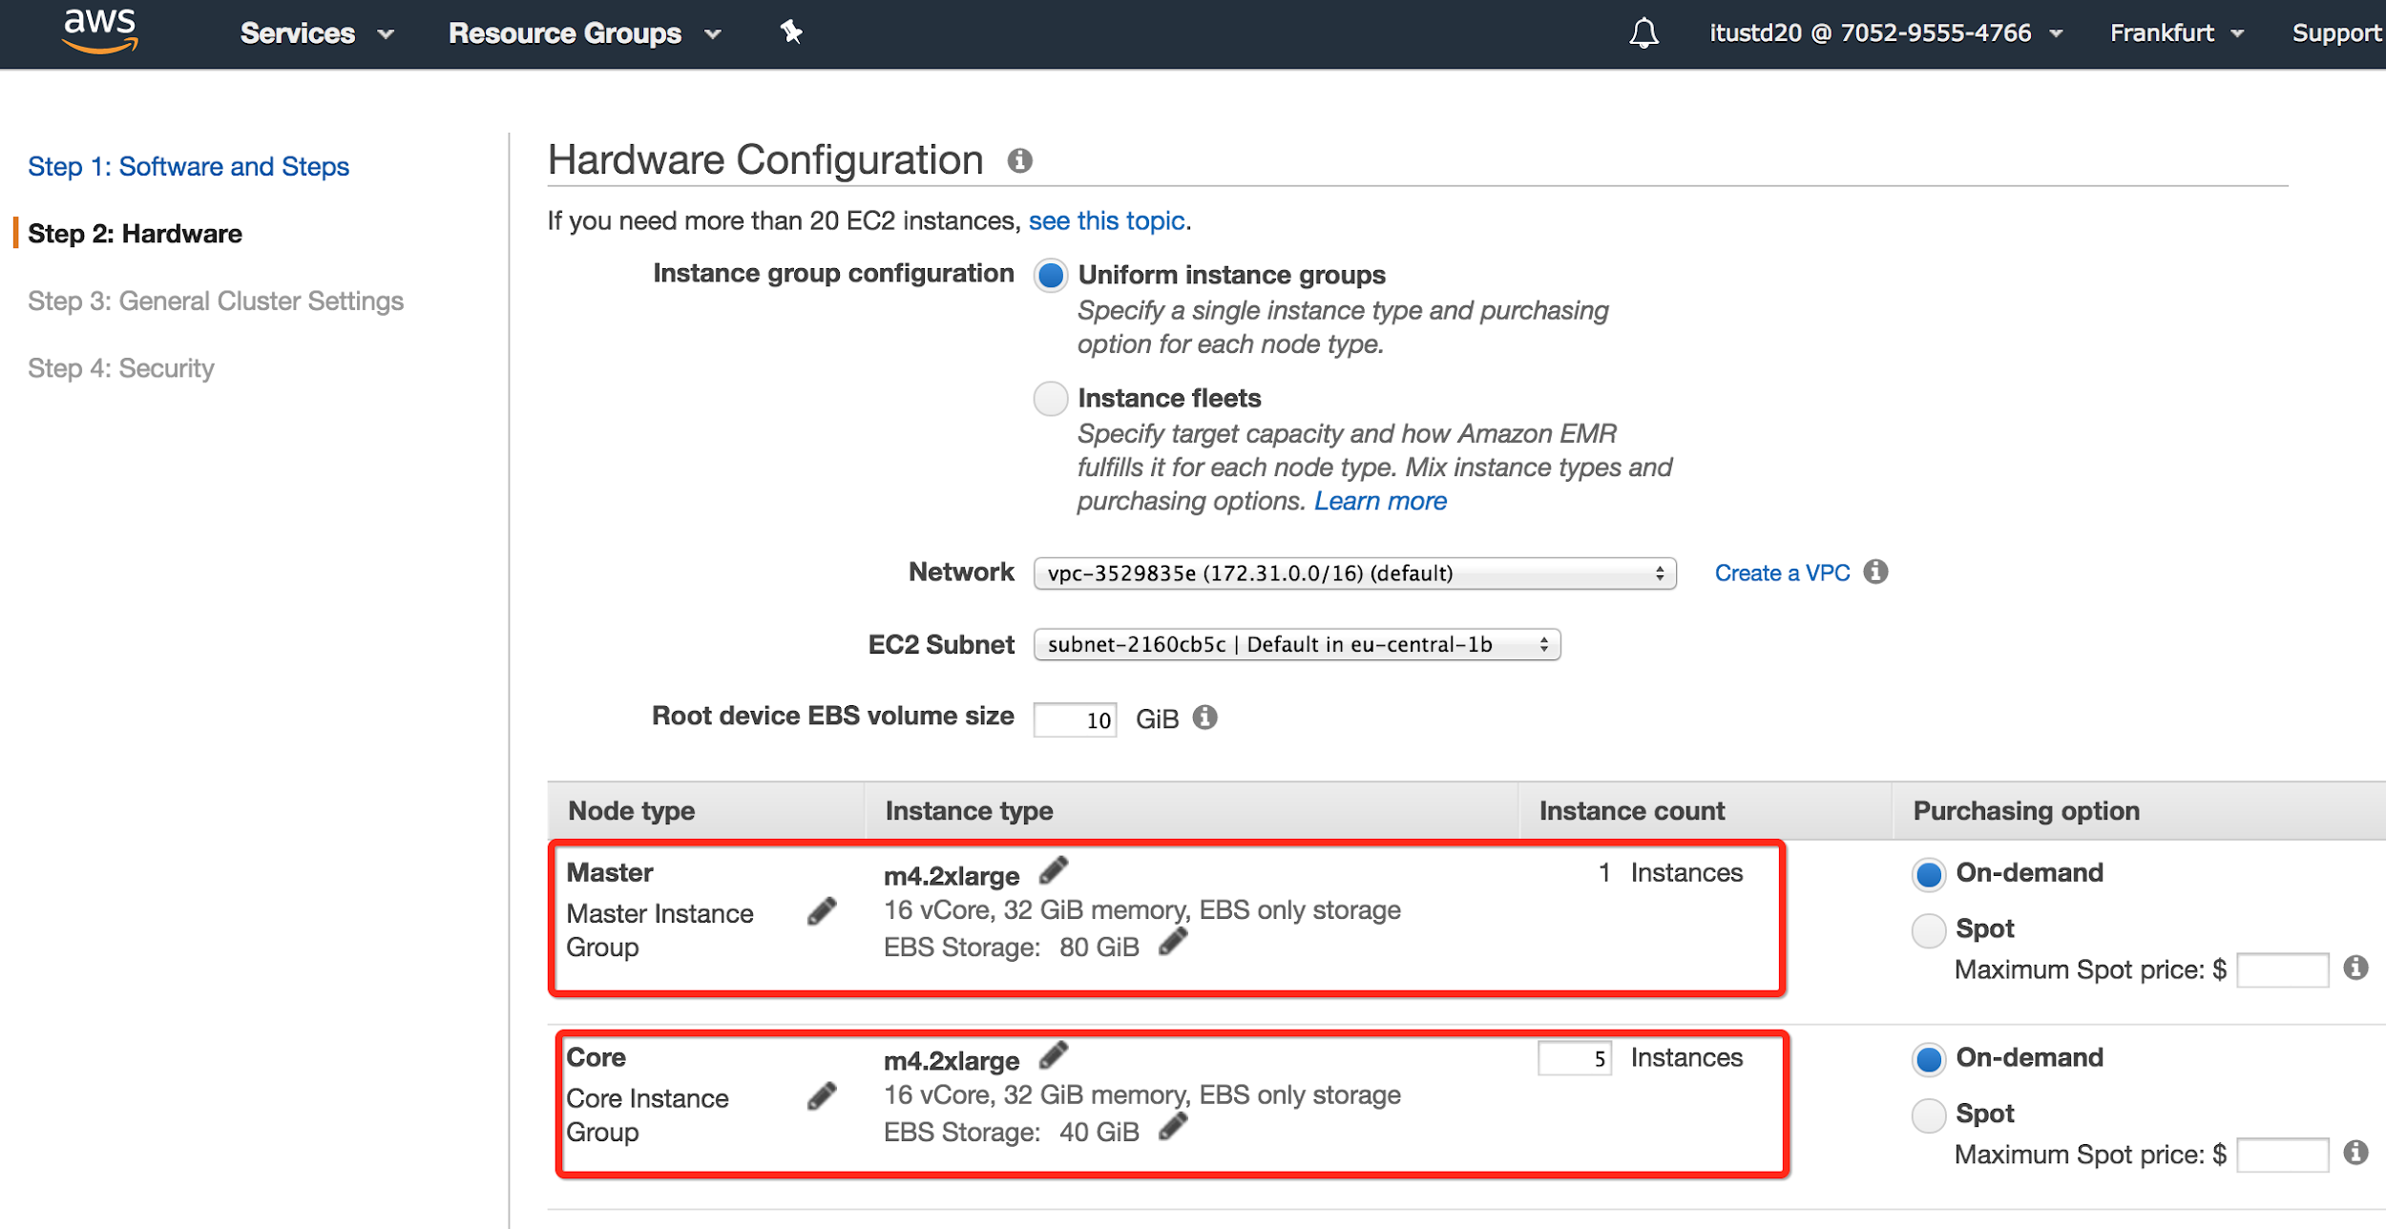

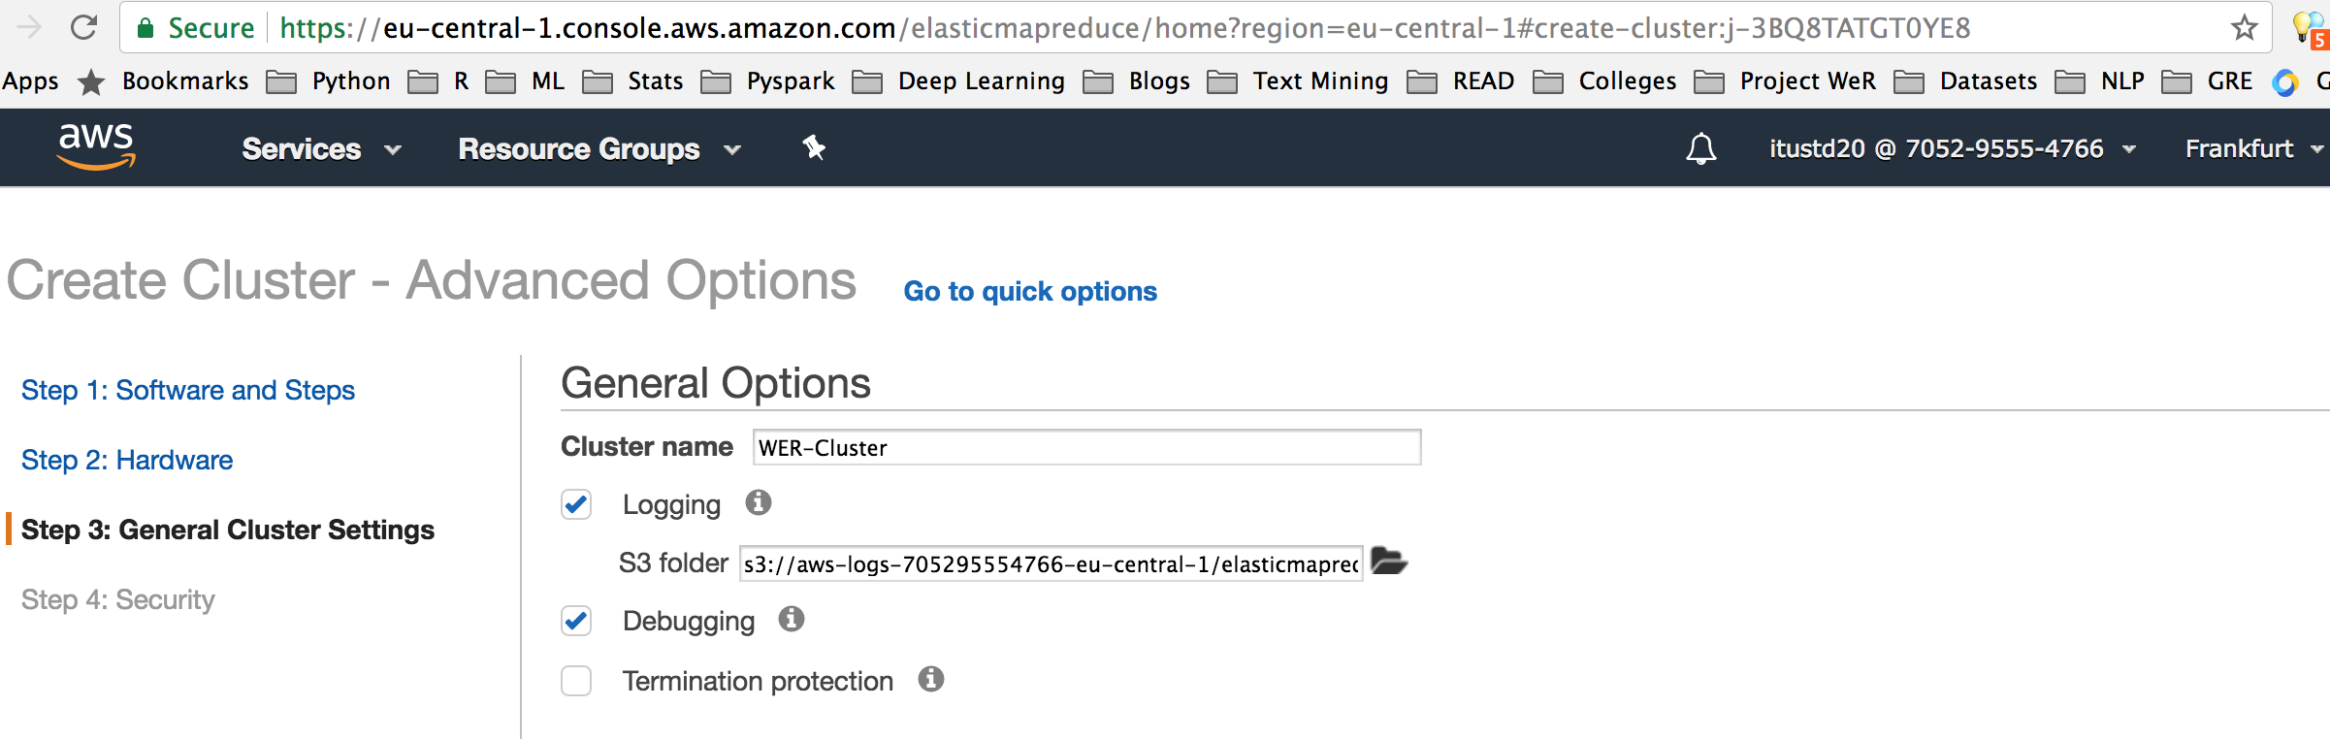

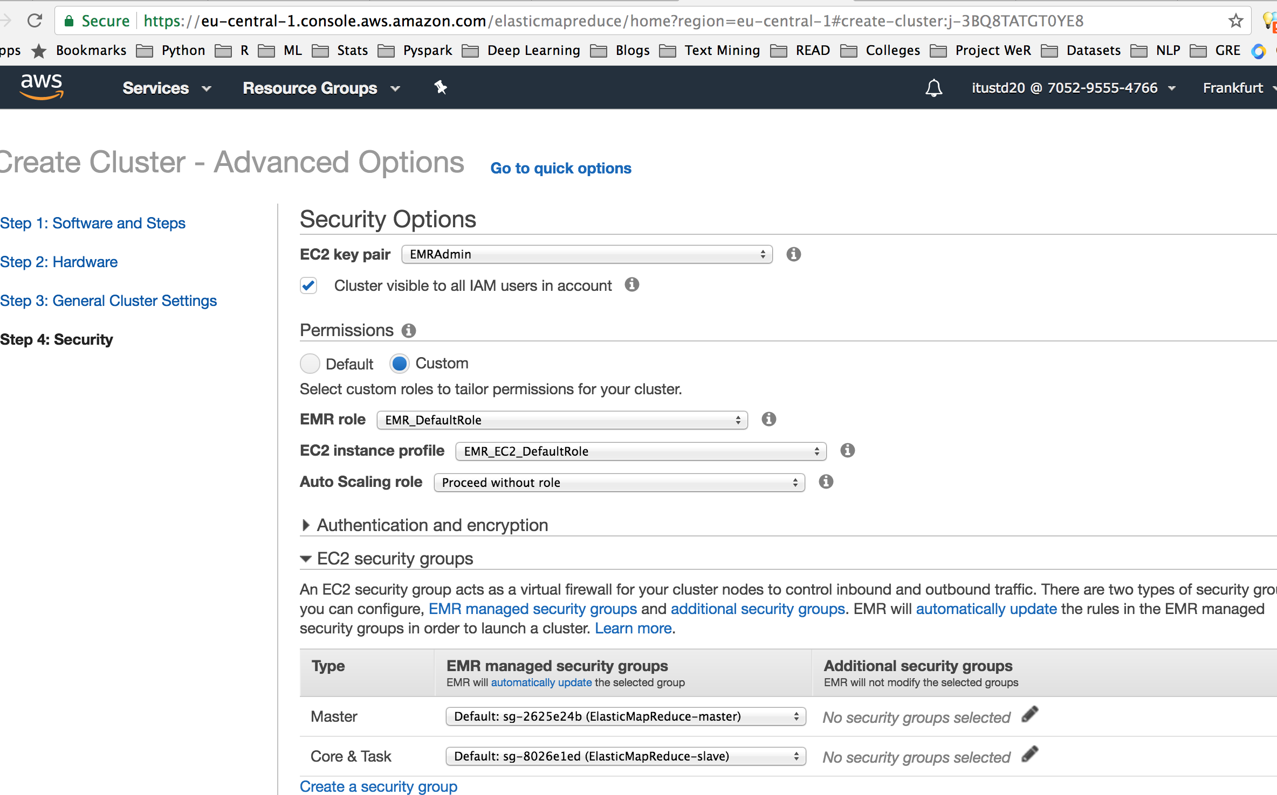

1. **Amazon S3**

Our datasets can be located at Amazon S3 in wer-amazon-review bucket.

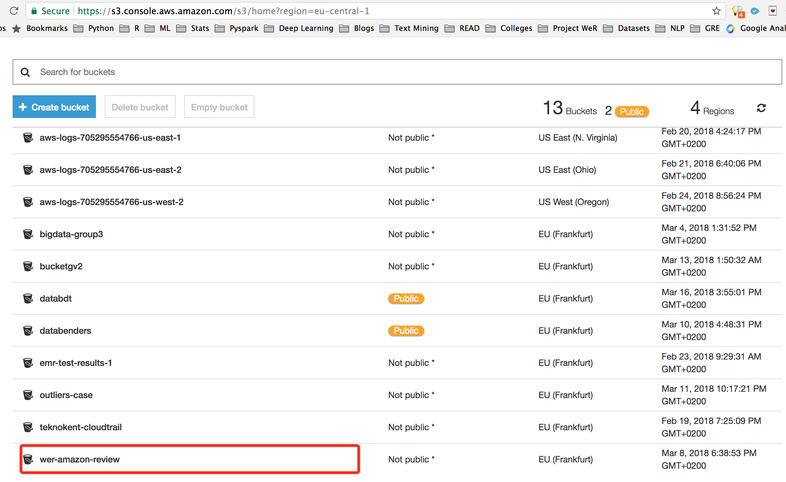

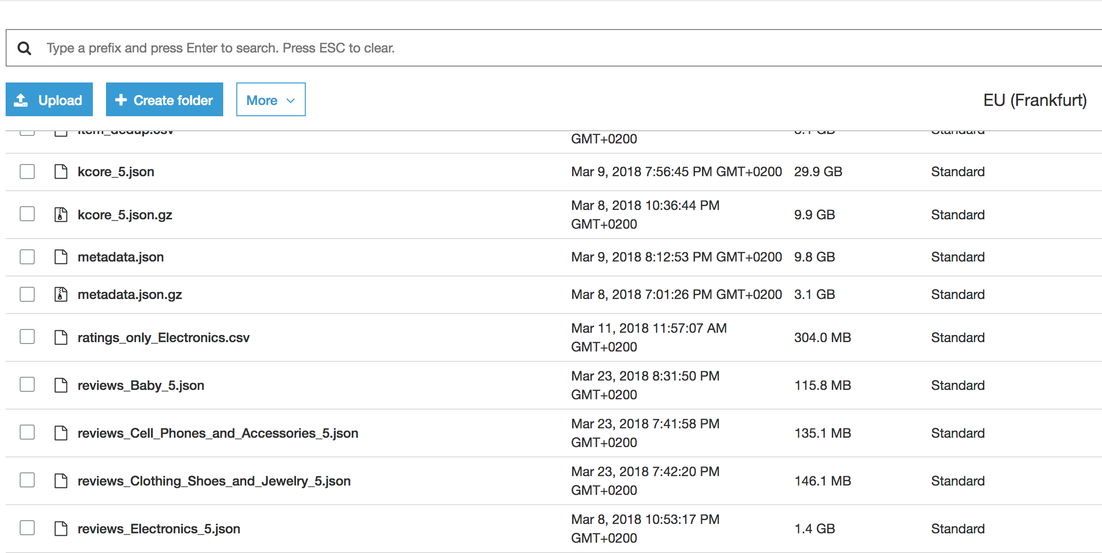

1. **Exploratory Analysis:**

Our initial goal was to apply different tools and techniques surrounding Spark and get exposed to working with different data formats such as csv and json. In order to achieve this, we performed an exploratory analysis on the dataset. This also helped us grasp the depth and variety of information in our dataset. Our data contains both qualitative and textual content. In this phase, we made much more analysis than what have been presented here. We selected the following use cases to showcase the range of techniques and syntax we have used.

1. **Restricted Distributed Dataset Method:**

For this part, you need

* terminal (you should open a terminal, type the path to Apache Spark and launch pyspark)
* WeR_Part1_RDD_Stats.py file
* ratings_Electronics.csv

First, we focused on analyzing the data through Restricted Distributed Datasets method. We read ratings_Electronics.csv file and mapped the lines splitted by a comma to values. By selecting the corresponding columns for users and products, we calculated number of distinct users and products in the dataset. Mean and variance were simply calculated using a statistics library from pyspark.

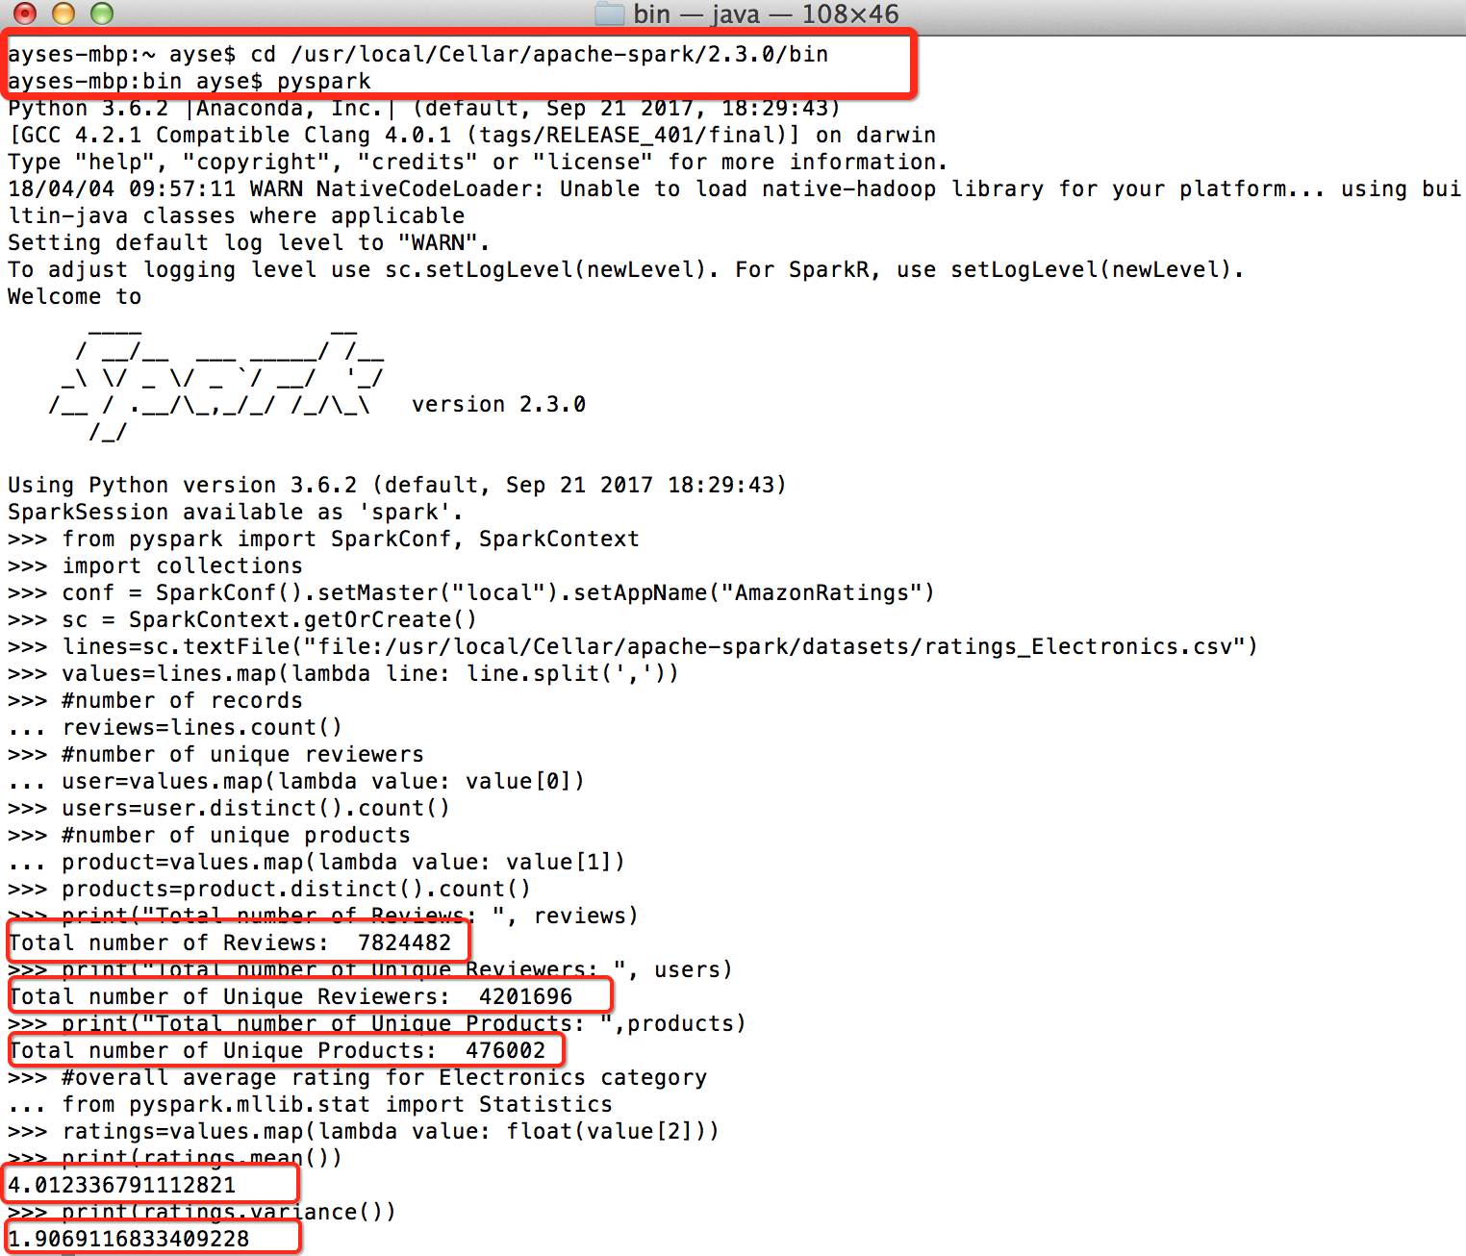

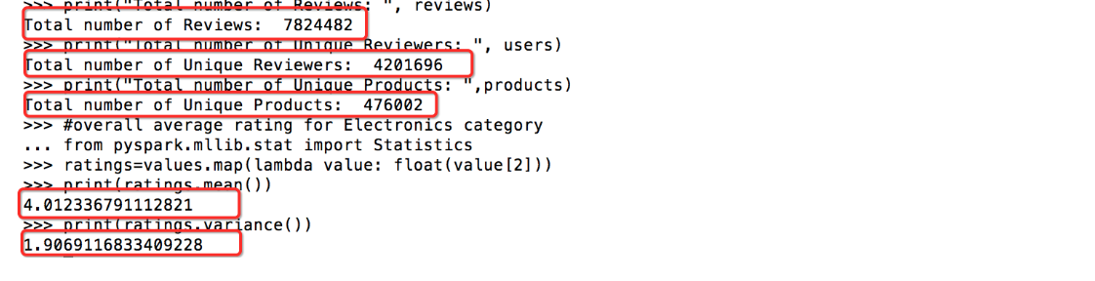

As the next step, ratings were counted and ratings distribution is presented first as an ordered dictionary data structure, then as a bar graphic drawn by matplot library. To plot the ratings, we had to unzip the values of x and y storing the ratings as an ordered dictionary. We frequently ran sum checks to ensure that our work is calculated correctly.

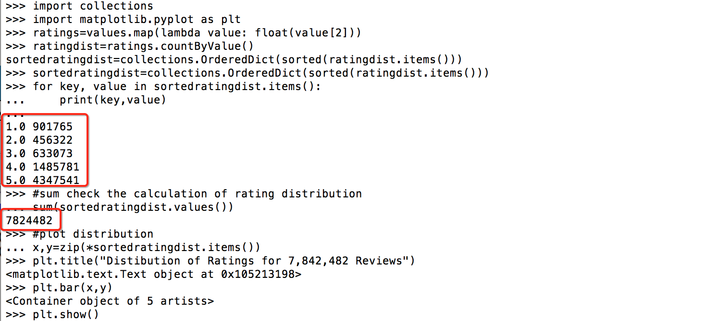

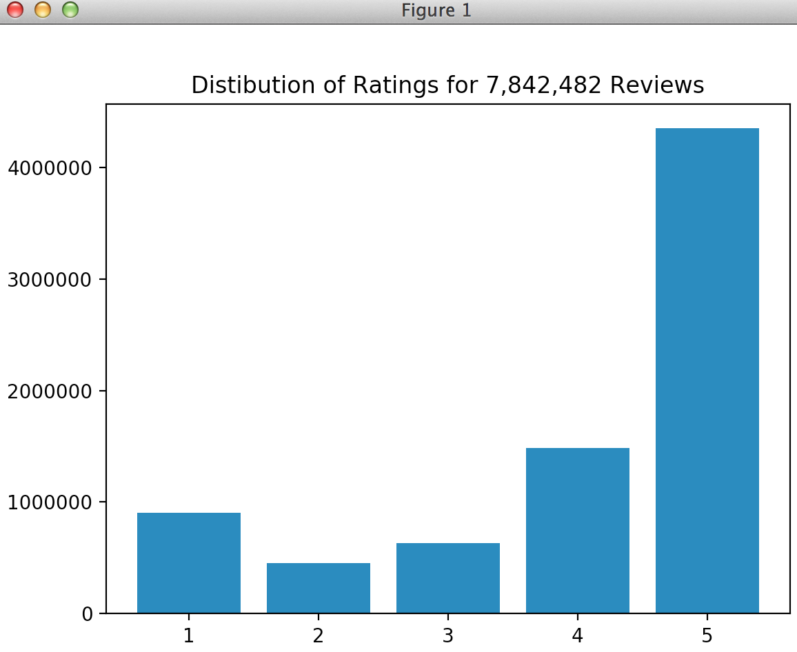

Then, we created pairs of productID and its ratings grouped by their keys (productID). Then, average rating of each product was calculated by simply dividing sum of ratings to size of ratings. In order to show how many unique products have a certain high or low average rating, we mapped average ratings to a variable and counted the values. The output was both printed line by line and on a bar graph using matplot library.

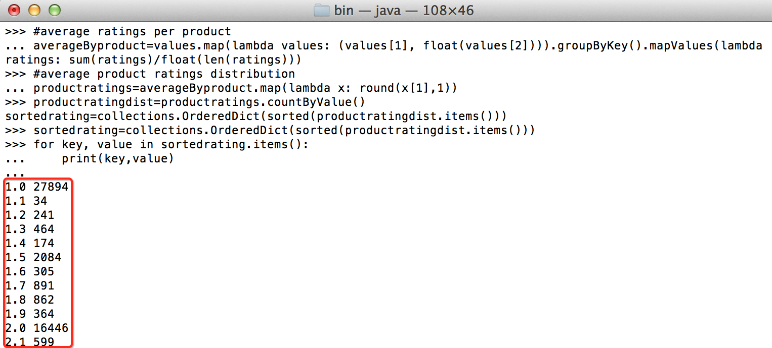

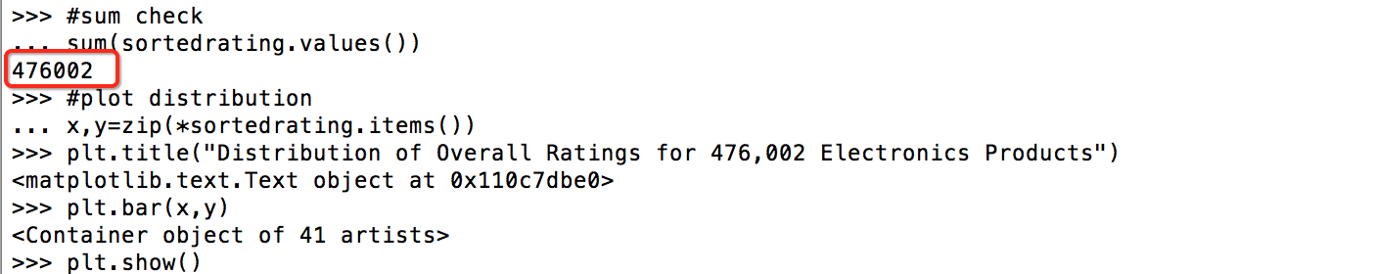

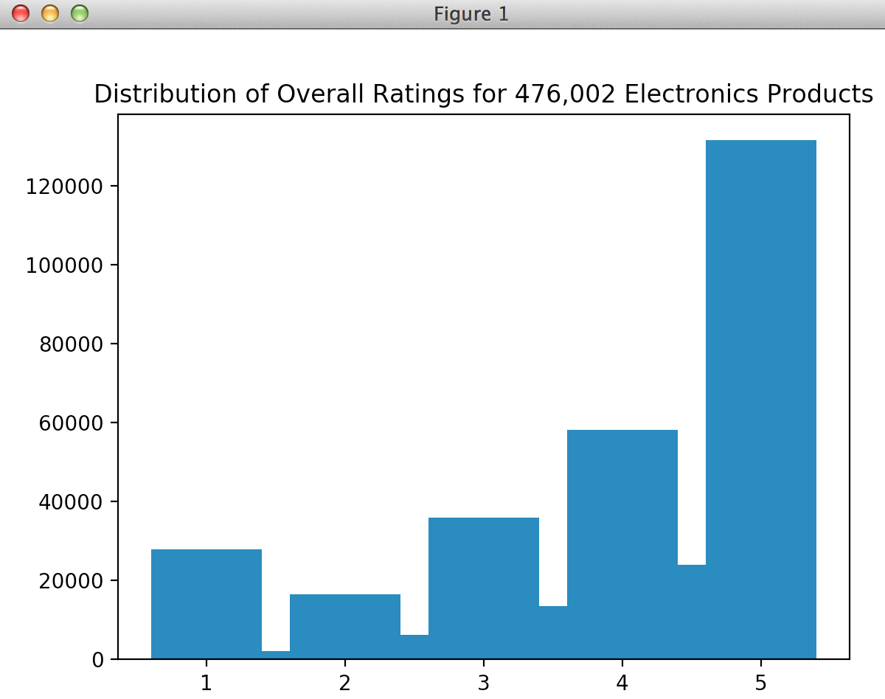

To calculate number of ratings given for each product, we mapped each product to 1 and reduce by key. Then, to list the products from most frequently rated to least we sorted output descendingly on values. The output was both printed and Most Rated Top 5 Products plotted on bar chart using matplot library.

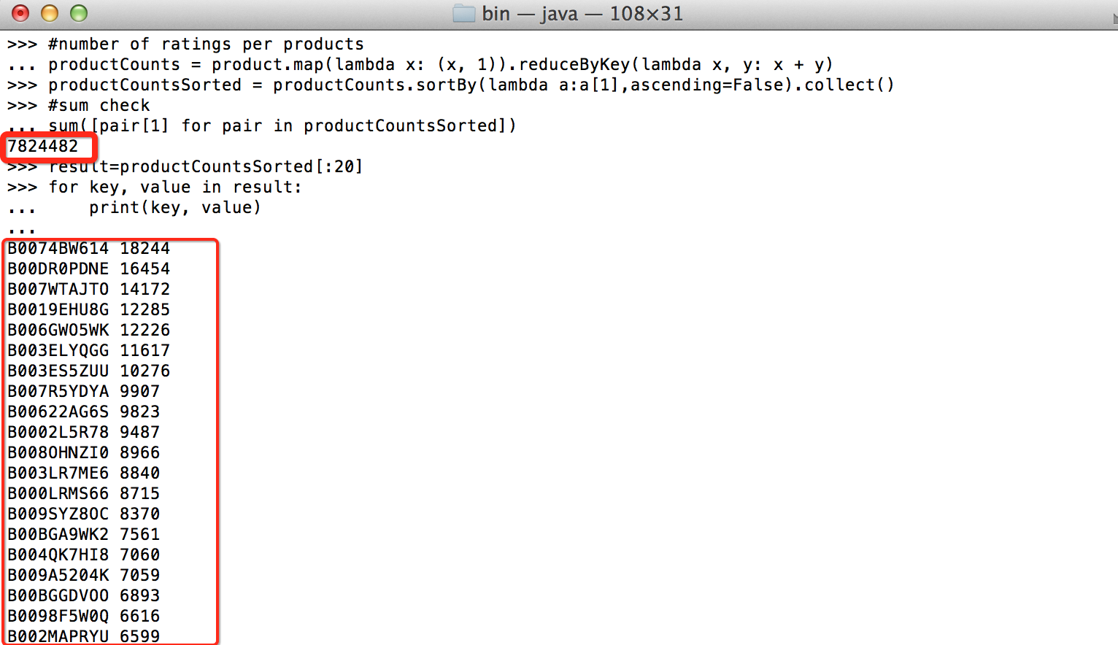

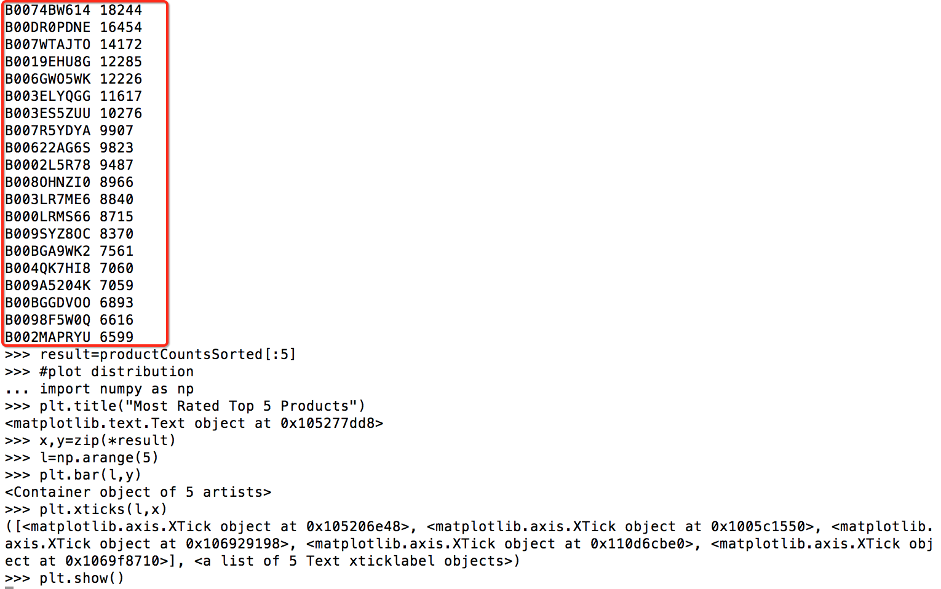

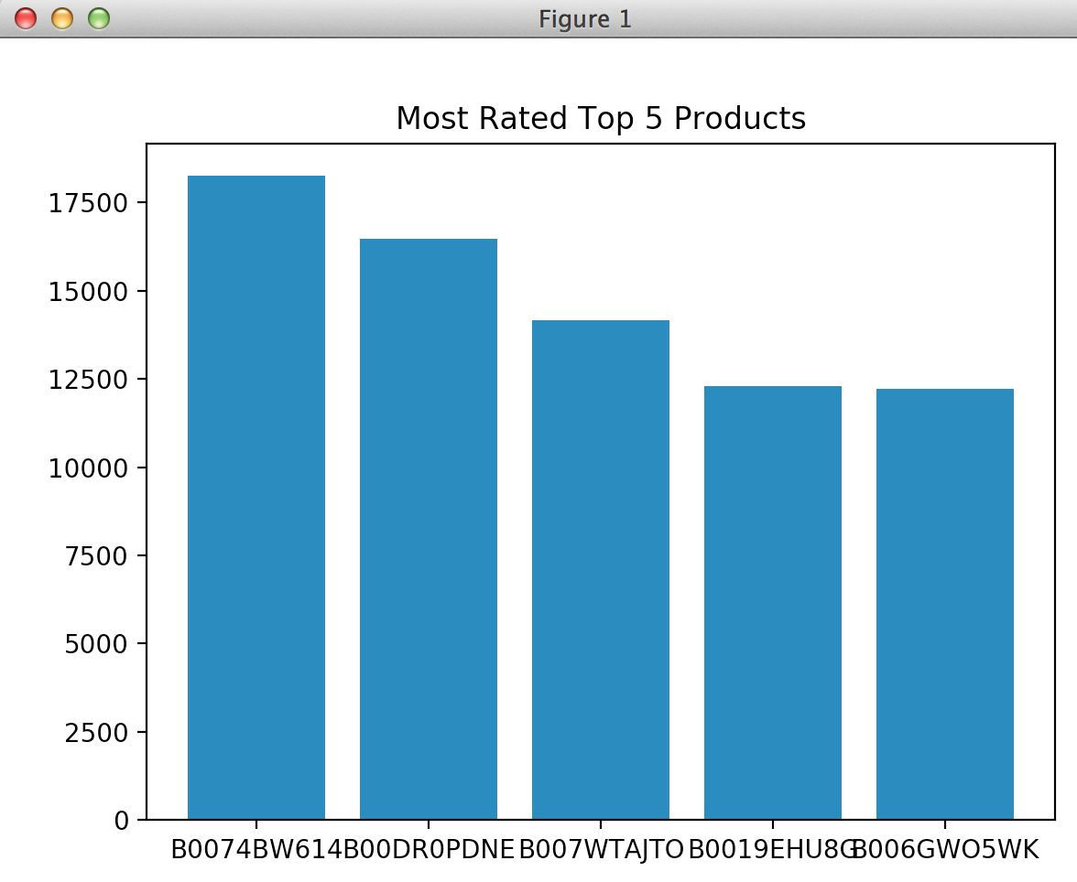

1. **Dataframe Method and Spark SQL:**

For this part, you need

* a cluster on Amazon ElasticMapReduce (flow the instructions on step 1 of this paper)
* WeR_Part2_EMR_SparkSQL_Stats.json file

When the cluster launches, click on **Zeppelin** link to open its interface where you can **import note**. You should select **choose a JSON file** and import WeR_Part2_EMR_SparkSQL_Stats.json into Zeppelin. To open this note, click on its link which will launch a new tab on your browser.

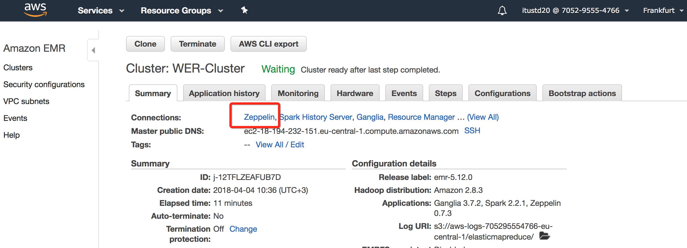

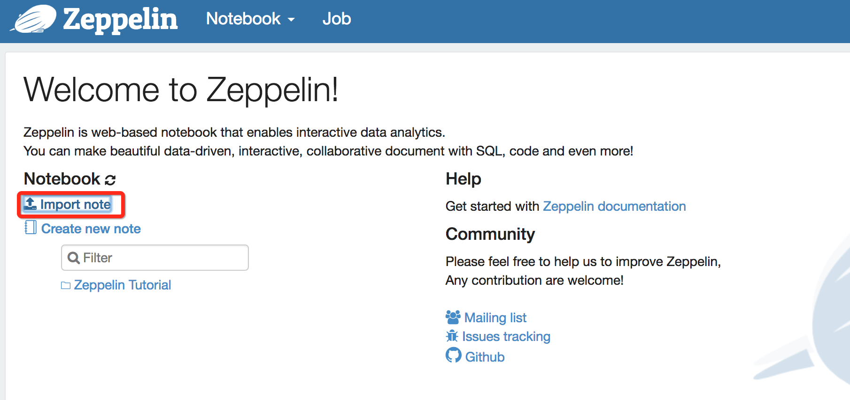

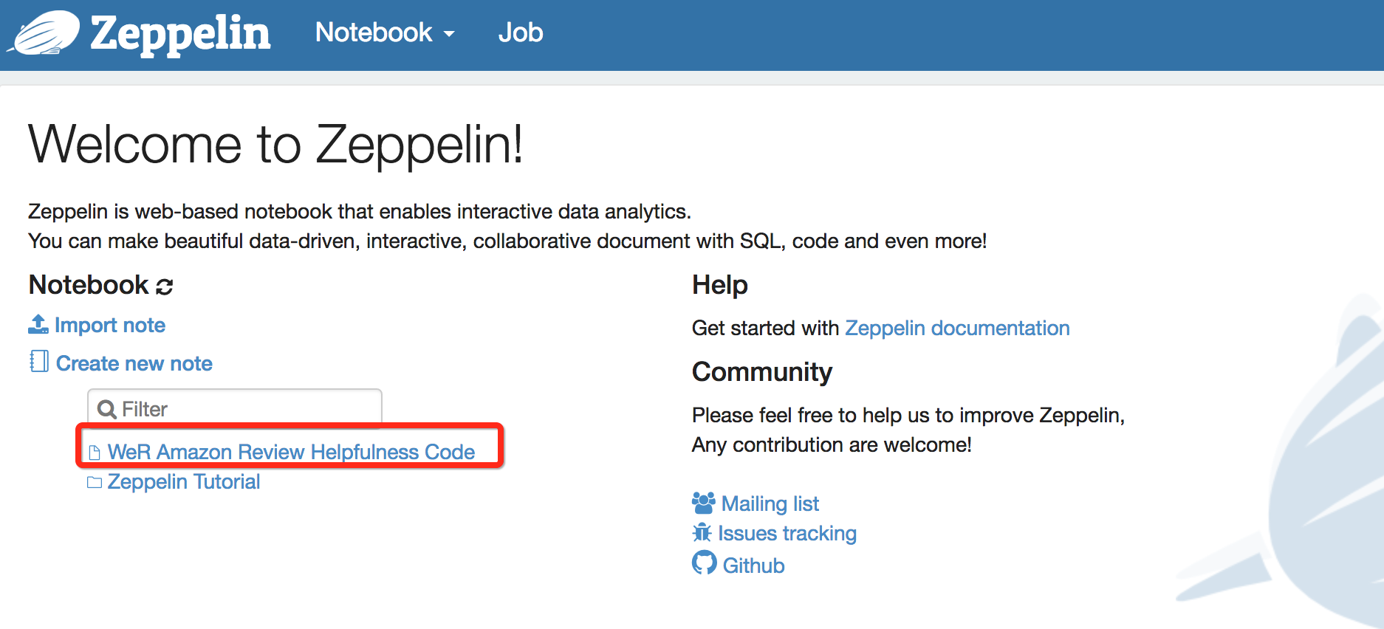

Here, we focused on analyzing the data through Spark Dataframes. We read the json file and occasionally used cache() to access data faster from memory. To check each column’s data format in the file we used printSchema() and used describe() to obtain a high level statistics of a given column.

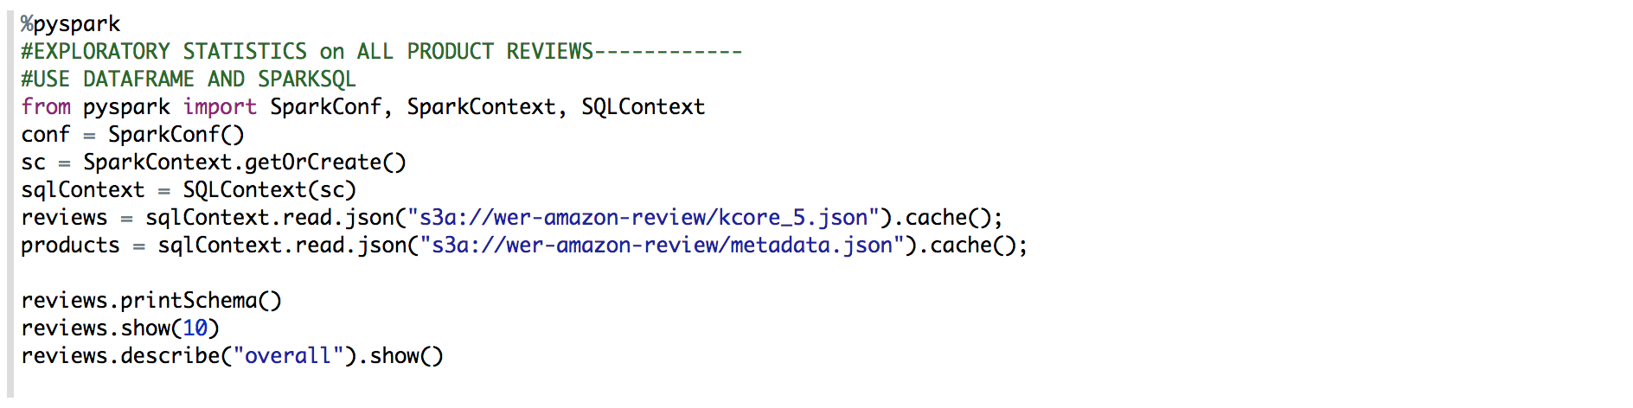

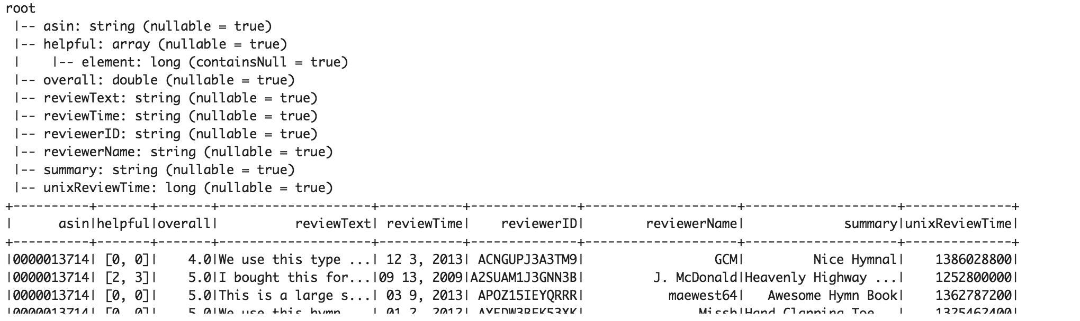

As mentioned before we have various datasets with different content. To show top rated products, first we read the deduplicated file where we mapped user, asin, rating and timestamp and cached it to memory. Then we read the metadata file containing names of products associated with each asin number. We counted number of ratings by grouping by asin and sorting the result in descending order. Finally, we joined two dataframes to display names of products and counts.

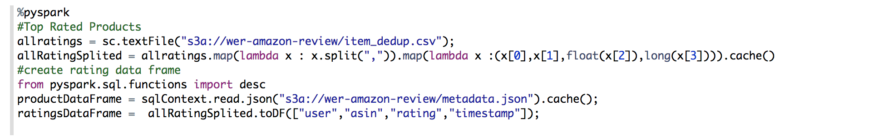



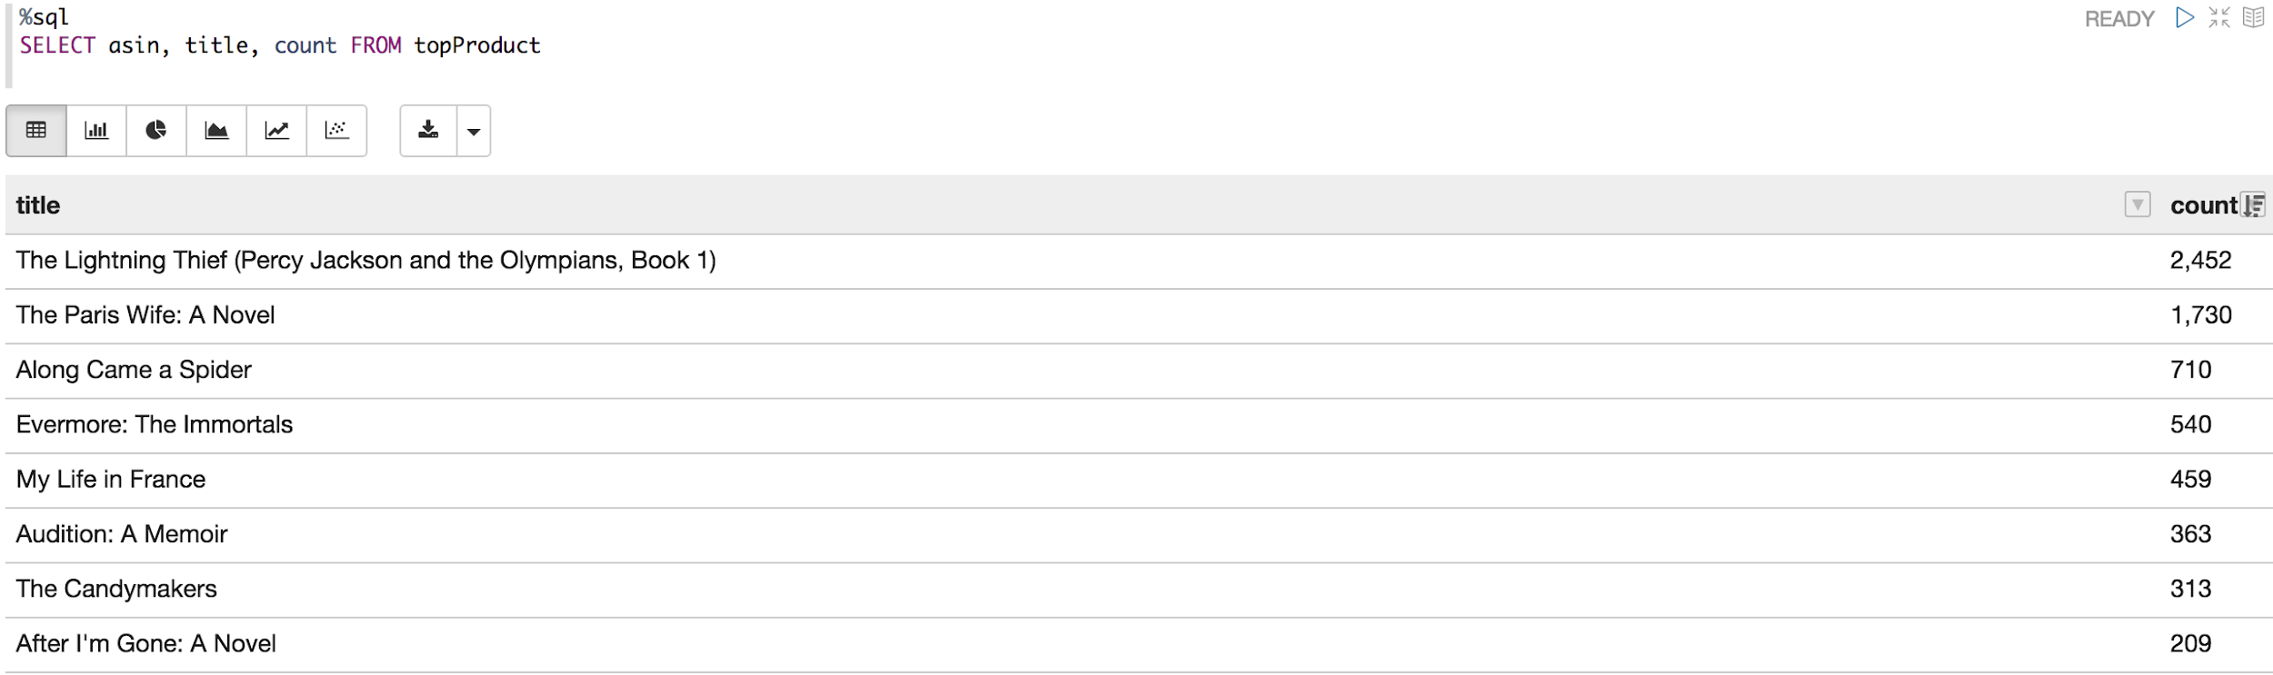

To compute distribution of ratings by year, we imported datetime, user defined function and string type from pyspark.sql. We defined a function to convert timestamp into year format and added a new “year” column into ratingsDataFrame allowing us to query dataframe with SparkSQL.

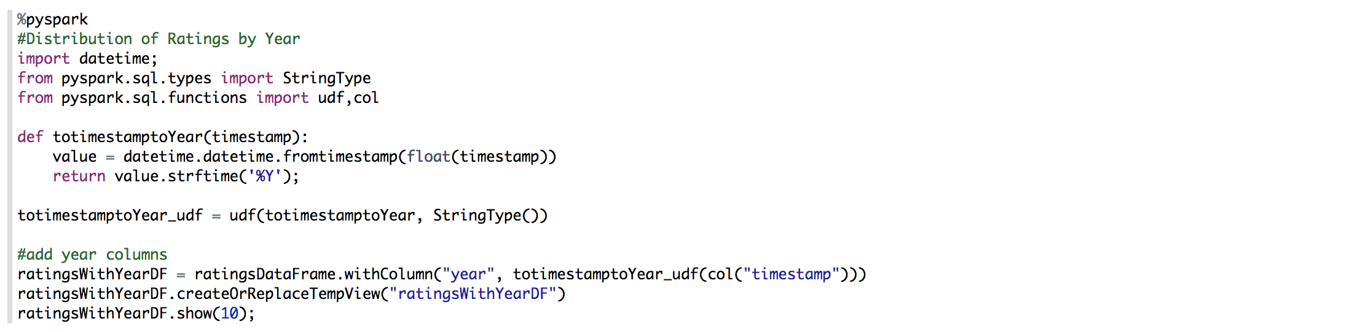

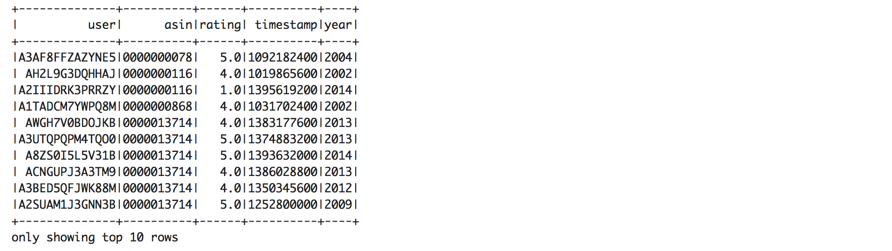

Here is the number of ratings by year:

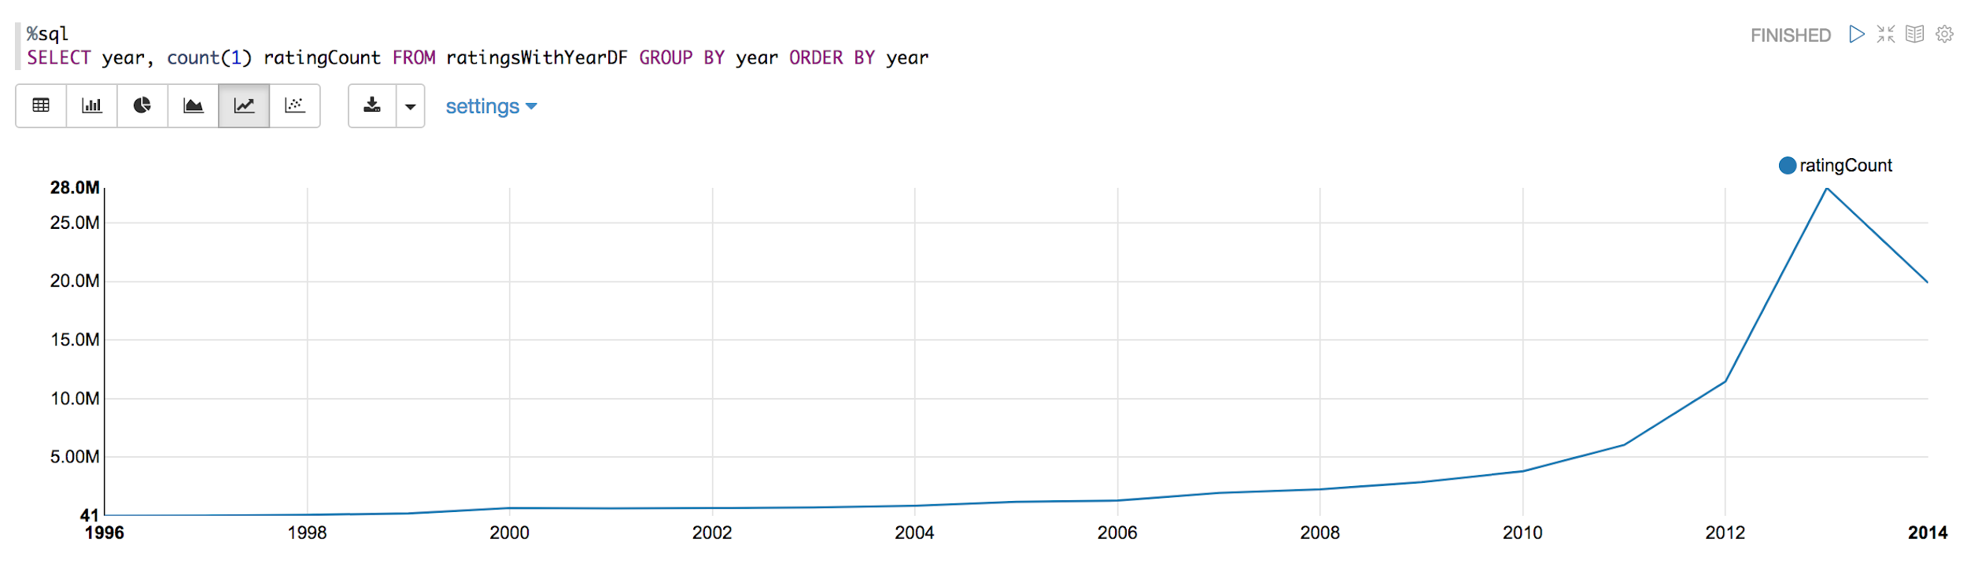

To compute distribution of reviews by year, we converted unixReviewTime into year format and added a new “year” column into reviewsDataFrame allowing us to query dataframe with SparkSQL.

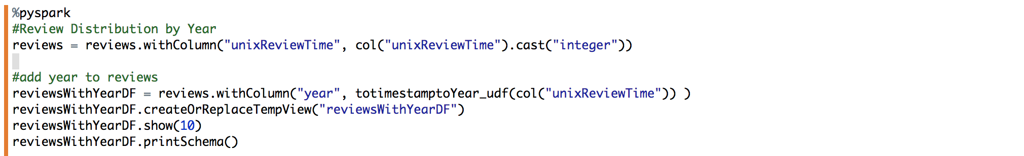

Here is the number of reviews written each year:

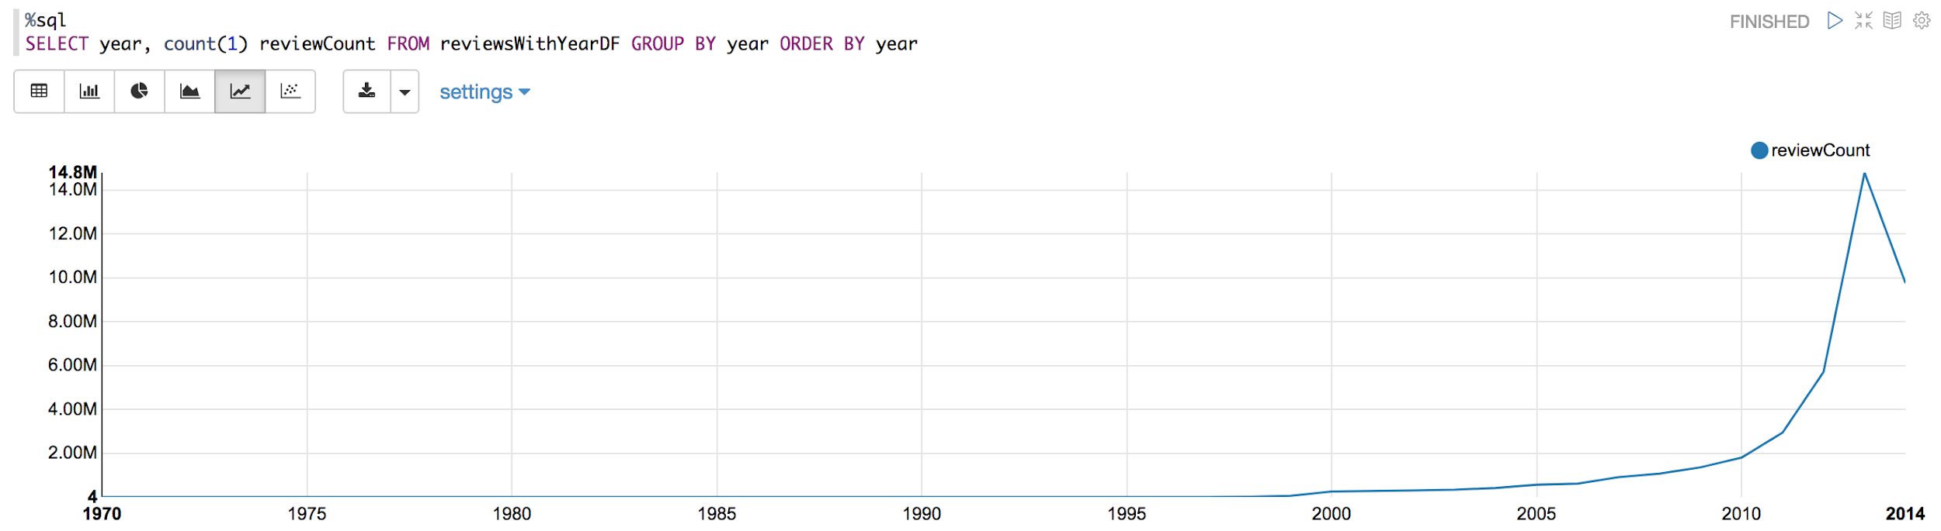

Here is the number of unique reviewers by year:

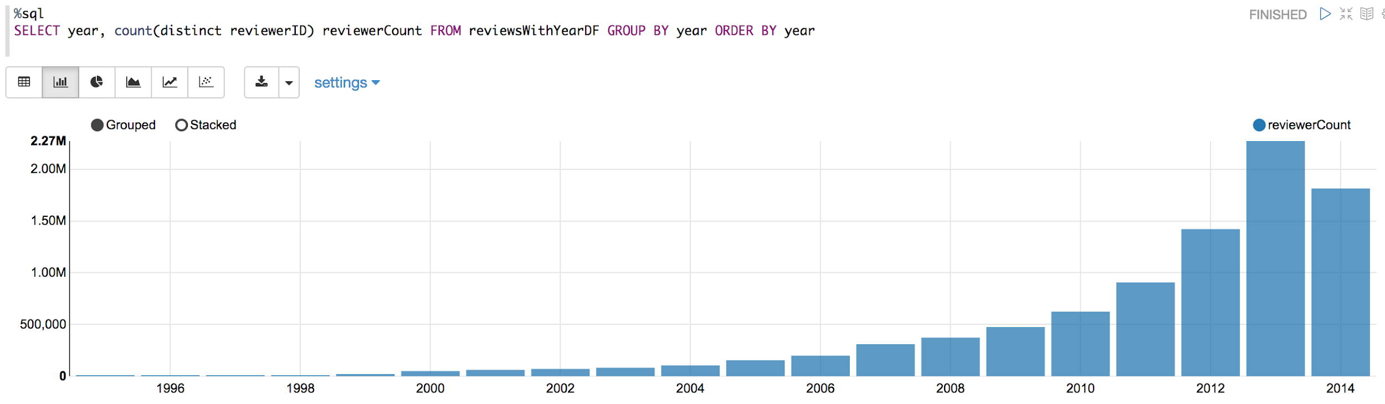

To compute top contributors (both as reviewer and rater), we imported functions from pyspark.sql and counted by grouping reviews and ratings by year and reviewer/user. After sorting both in descending order we joined both dataframes.

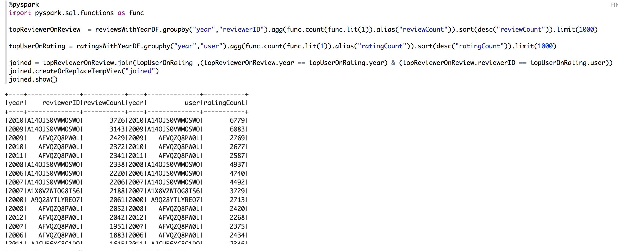

**3. Prediction Model of Helpfulness Score for Amazon Reviews:**

For this part, you need

* the cluster on Amazon ElasticMapReduce
* WeR_Part3_EMR_ML.json file

As described in step 2 of this paper, we need to first import note “WeR_Part3_EMR_ML.json” into **Zeppelin**. First, we focused on engineering features that would be used in predicting helpfulness scores of reviews.

We imported necessary SparkConf, SparkContext and SQL Context libraries and read kcore_5 and metadata.json files.

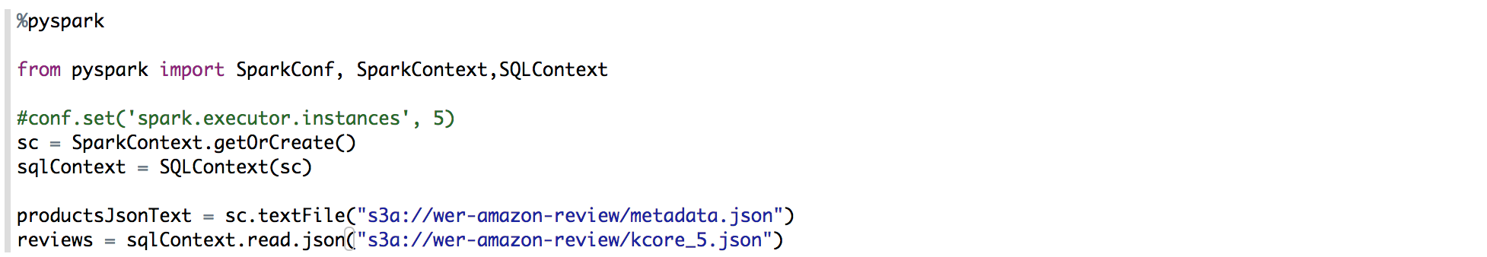

We calculated number of reviews of each product to be used as a feature in the prediction model.



Then, we converted product.json to tuple based on key (asin), value pair RDD.

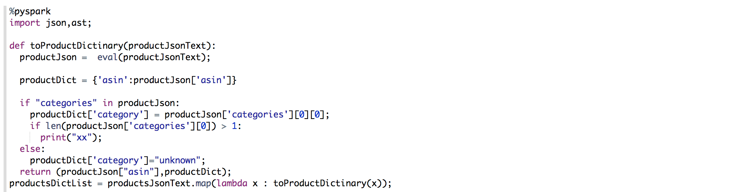

For each product , its number of reviews (reviewCount) was added.

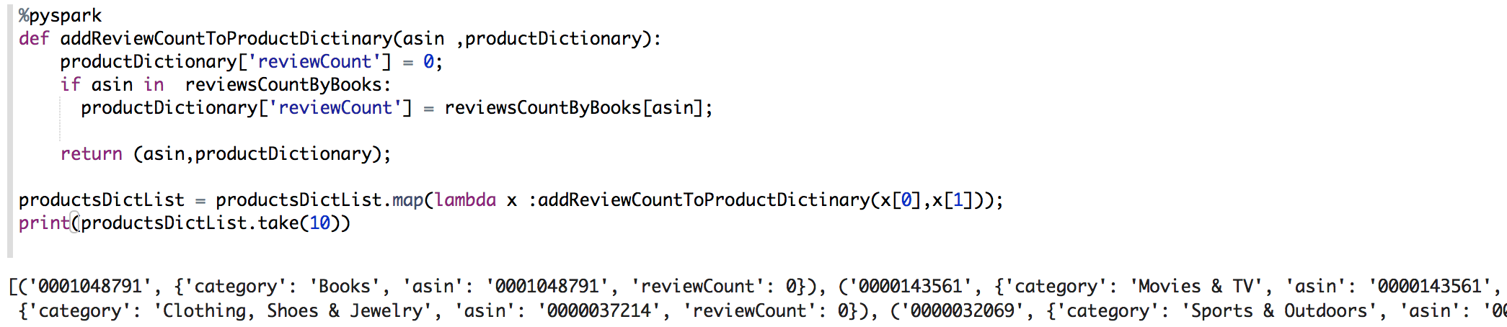

We only broadcasted product review count tuple as map (that is dictionary). In fact, we tried to broadcast productDictionary but we received errors related to memory in spark context.



Then, we added new columns for review length, summary length, product category and product review count to our reviews dataframe to be used in the prediction model.

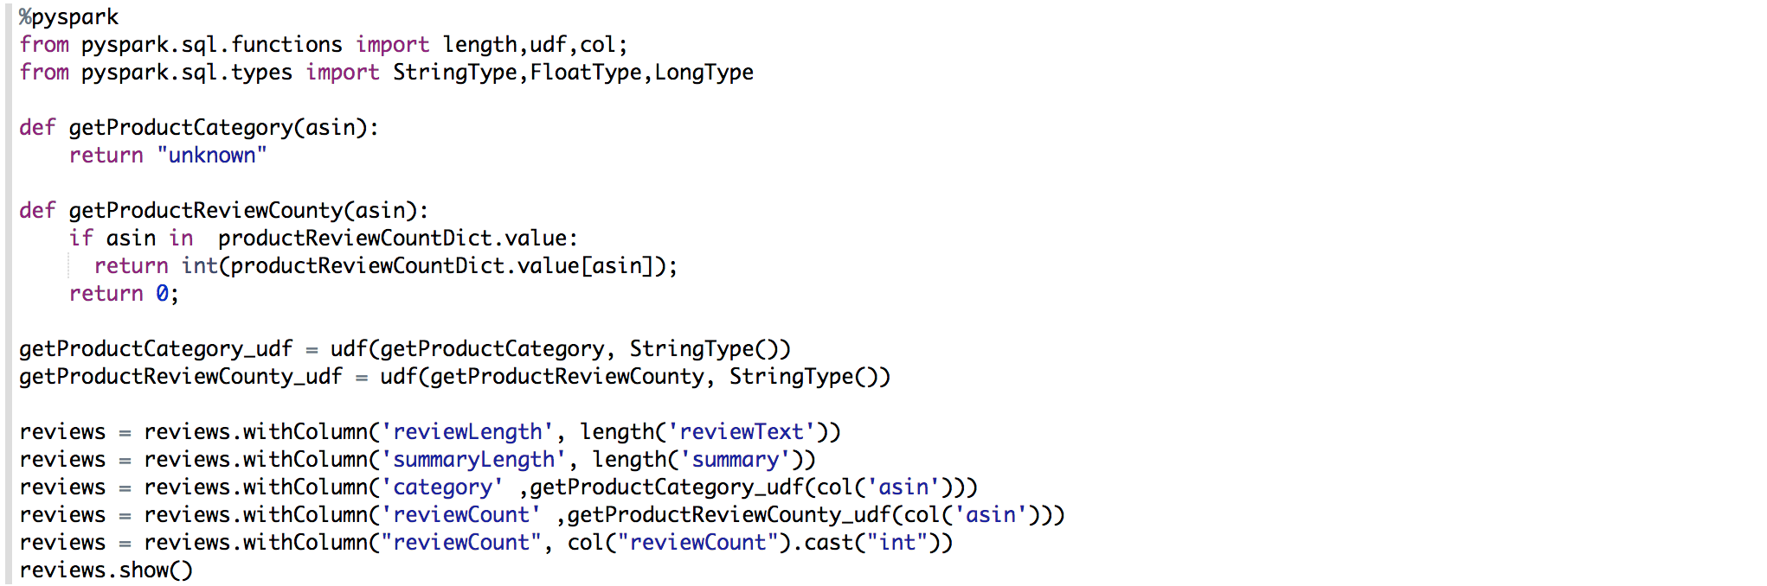

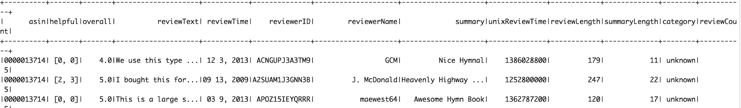

Helpful score was an array in format [a,b] representing number of votes received as helpful out of total votes.



First, we divided a by b to convert helpful score to a ratio. Then, SQL was used to convert “Helpful Score” to a binary output. If Helpful Score is greater than 0.6, it was converted to 1, else to 0.



In this part, we used tokenizer to separate each word in a product review and then removed stop words in order to remove meaningless words like “I, we, the, etc.”.

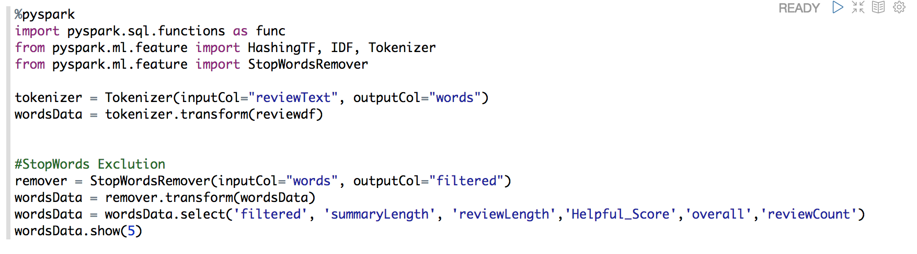

TF-IDF vectorization method had been used in this part. It is intented to measure how important a word is to a review in a collection of reviews.

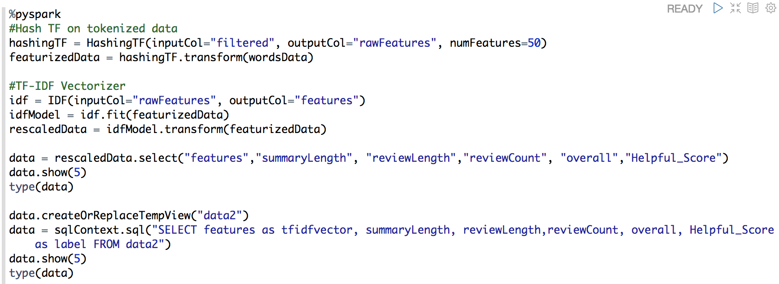

Vector assembler had been used in order to merge other features (like review lenght) with TF-IDF vector.

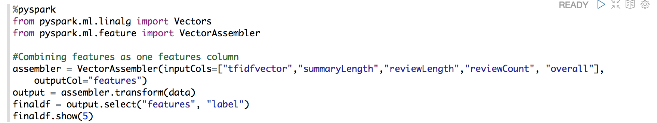

Train-test split with 0.7-0.3 proportion.

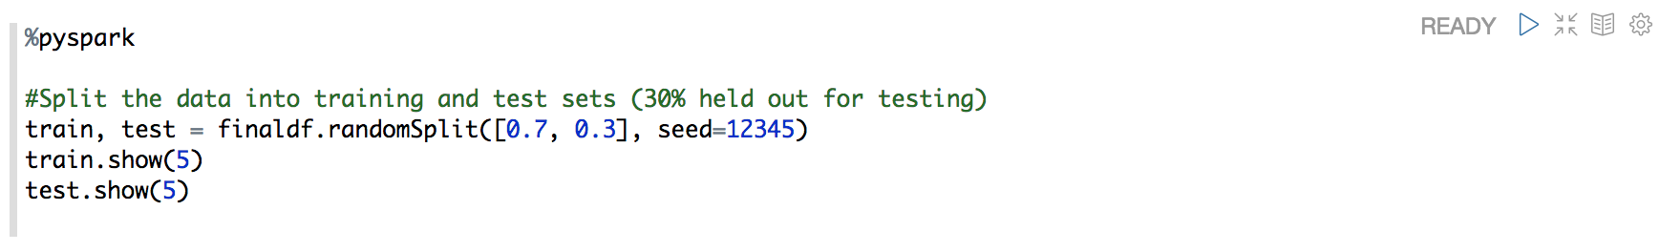

Our first model is Random Forest classifier. Since we had tried to predict binary output, we had used classifiers. Model had been trained with 20 trees (Can be improved via parameter testing). We have test error and accuracy results for label prediction.

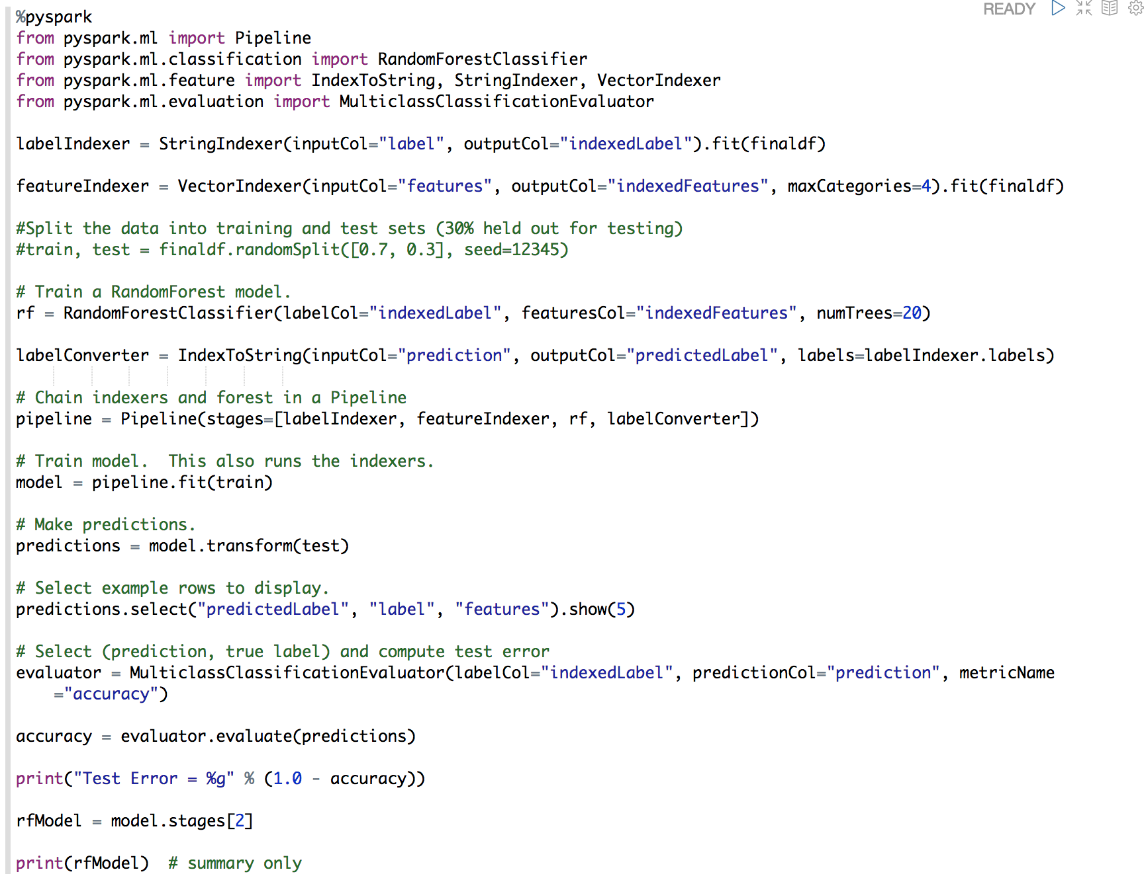

Our second model is Gradient Boosting classifier. Gradient Boosting is one of the most powerful techniques for building predictive models. Model had been trained with 20 trees (Can be improved via parameter testing). We have test error and accuracy results for label prediction.

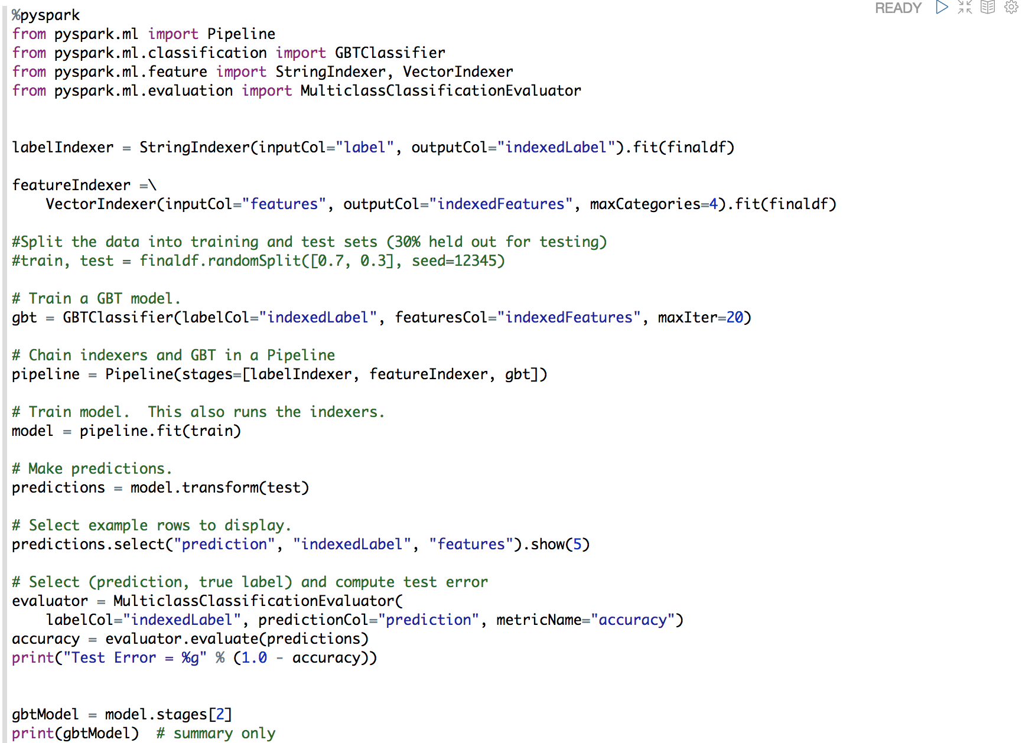

Our third and last model is Naive Bayes method. It didn’t perform well comparing the Random Forest and Gradient Boosting.

